**Helpmate Figma Prototype**

Designed By: Alice Kuang

Design Date: 10/11/22

Link: <https://www.figma.com/file/rrtwEyAZUrpVJWc9CK8bgw/Helpmate-Proto?node-id=0%3A1>

Overview from row 2, left to right: login, homepage, column of modules, streaks

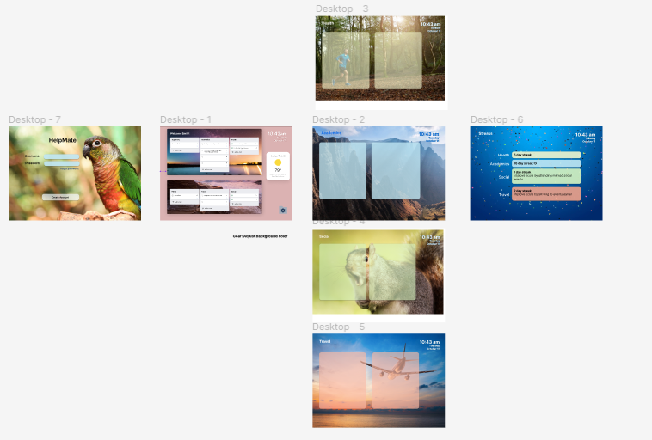

Login prototype:

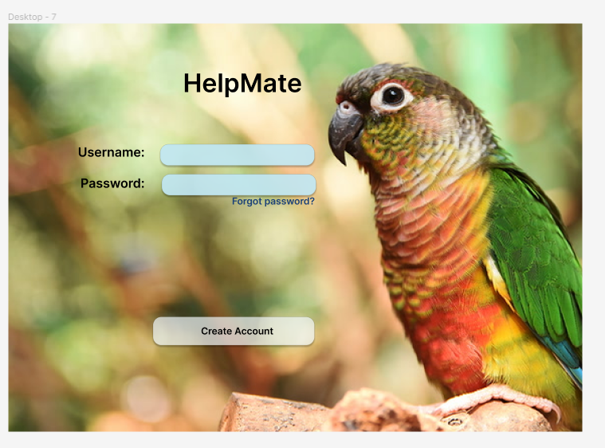

Homepage prototype (version 1):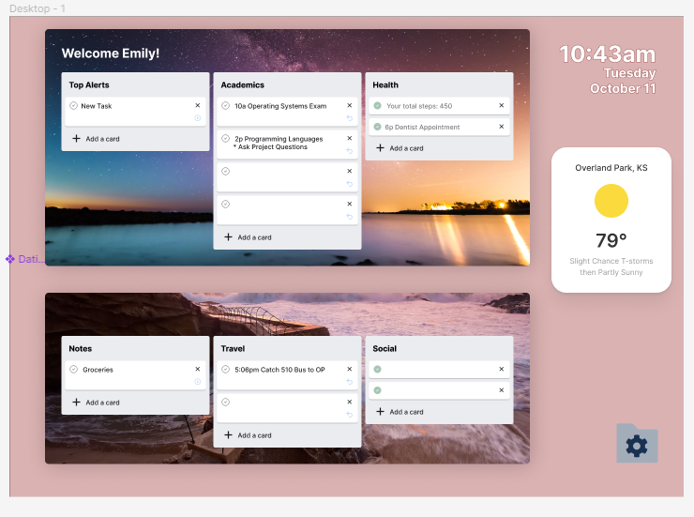

Module sample prototype (Work in Progress):

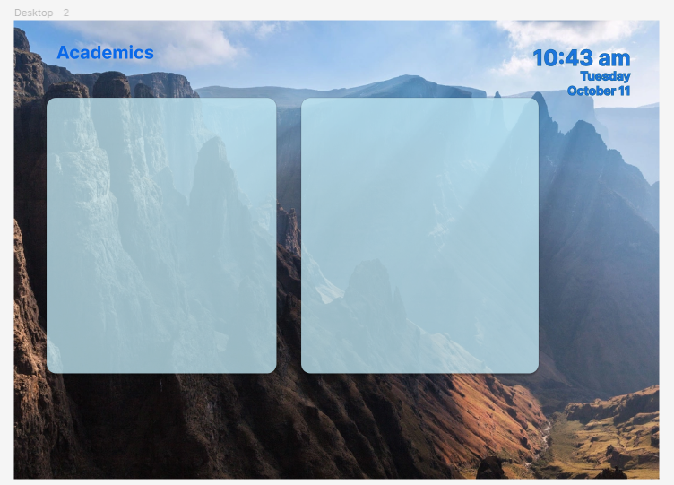

Streaks Page:

